**FUTURE SALES PREDICTION - PHASE 2**

**INTRODUCTION:**

In the world of business, the ability to predict future sales is of paramount importance. Accurate sales forecasts empower companies to make informed decisions, allocate resources efficiently, and stay ahead in the competitive landscape. One powerful tool at the disposal of businesses for this purpose is time series forecasting. Time series forecasting is a specialized field within data analysis that focuses on understanding and predicting future values of a variable based on its historical performance over time.



**TECHNIQUES FOR FUTURE SALES PREDICTION:**

Advanced time series forecasting involves using sophisticated statistical and machine learning techniques to make predictions about future data points based on past time series data. Time series data is sequential and typically represents how a variable changes over time, making it suitable for forecasting future values. Here are some advanced methods and approaches for time series forecasting:

**ARIMA (AutoRegressive Integrated Moving Average):** ARIMA is a classical time series forecasting method that combines autoregressive and moving average components. ARIMA models are often extended with seasonal components, resulting in SARIMA models, which are capable of handling seasonality in the data.

**Exponential Smoothing (ETS):** Exponential smoothing methods are based on weighted averages of past observations. They include simple exponential smoothing, Holt's linear method, and Holt-Winters method, which can handle various levels of trend and seasonality in the data.

**Prophet:** Developed by Facebook, Prophet is a forecasting tool designed for business time series data. It can handle daily observations that display patterns on different time scales, including holidays and special events.

**Long Short-Term Memory (LSTM) Networks:** LSTM is a type of recurrent neural network (RNN) that can capture long-term dependencies in time series data. LSTMs are particularly effective for sequences with irregular patterns and complex dependencies.

**Convolutional Neural Networks (CNNs):** CNNs, which are primarily used in image processing, can also be applied to time series data. They are useful when patterns in the time series can be represented spatially.

**Gated Recurrent Units (GRUs):** GRUs are another type of RNN, similar to LSTMs, and can be used for time series forecasting. They are computationally efficient and suitable for many time series problems.

**Seasonal Decomposition of Time Series (STL):** STL decomposes a time series into seasonal, trend, and remainder components. This decomposition can help in modeling and forecasting each component separately.

**State Space Models:** These models, including the Structural Time Series (STS) model, decompose a time series into various components, making it easier to analyze and forecast each component independently.

**Bayesian Structural Time Series (BSTS):** BSTS is a Bayesian approach to time series forecasting, allowing for uncertainty estimation and the incorporation of multiple predictors.

**Hybrid Models:** Combining different forecasting methods can often yield better results. For example, you can use ARIMA to model the trend and seasonality and then add a machine learning model to capture more complex patterns.

**Ensemble Methods:** Combining the forecasts from multiple models, such as Random Forests or Gradient Boosting, can improve accuracy by reducing individual model biases.

**Transfer Learning:** In cases where data is scarce or the time series is short, you can leverage pre-trained models or knowledge from related time series to improve forecasting.

**Anomaly Detection:** Detecting anomalies within time series data can be crucial for forecasting. Identifying and handling outliers or irregular patterns is essential for accurate predictions.

**Feature Engineering:** Preprocessing and creating relevant features from the time series data can greatly improve forecasting performance.

**Hyperparameter Optimization:** Tuning the hyperparameters of forecasting models is essential for obtaining the best results. Techniques like grid search or Bayesian optimization can be used.

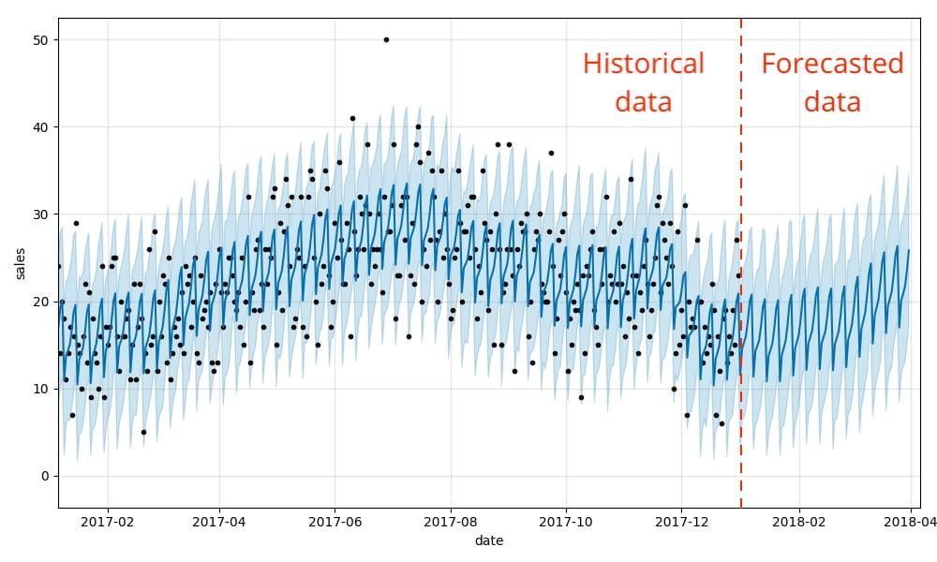

**IMPORTANCE OF SALES PREDICTION:**

**Demand Management:** Accurate sales forecasts enable businesses to anticipate customer demand and ensure that products or services are available when and where they are needed.

**Resource Allocation:** Predicting sales aids in efficient resource allocation, ensuring that companies invest their capital, labor, and marketing efforts in the right places and at the right times.

**Financial Planning:** Businesses can create realistic budgets and financial plans based on expected sales, which is crucial for sustainable growth and profitability.

**Competitive Advantage:** Accurate sales predictions provide a competitive edge by allowing businesses to respond quickly to market changes and adapt their strategies accordingly.

**CONCLUSION:**

Time series forecasting is a powerful tool for businesses seeking to predict future sales. By analyzing historical sales data and understanding the underlying patterns, it enables organizations to make data-driven decisions, allocate resources efficiently, and maintain a competitive edge in their respective industries. In this rapidly changing business landscape, mastering the art of sales prediction through time series forecasting is essential for sustainable growth and success.